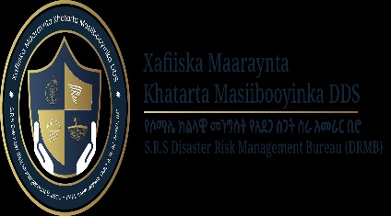 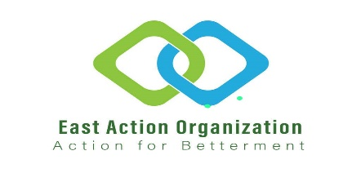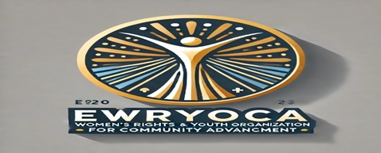

NARRATIVE REPORT ON FOOD ASSISTANCE TO VULNERABLE INDIVIDUALS IN JIGJIGA

Implemented by East Action and Ewryoca in Collaboration with the Somali Regional State Disaster Risk Management Bureau (SRS-DRMB)

Date of Implementation: March 10, 2025  
Location: Jigjiga Town, Somali Regional State  
Target Beneficiaries: 200 households (including impoverished persons, individuals with disabilities, and people living with HIV/AIDS)  
Indirect Beneficiaries: Approximately 1,200 individuals (based on an estimated household size of six members per family) according Somali regional population formula  
Estimated Cost per Household: 4,500 ETB

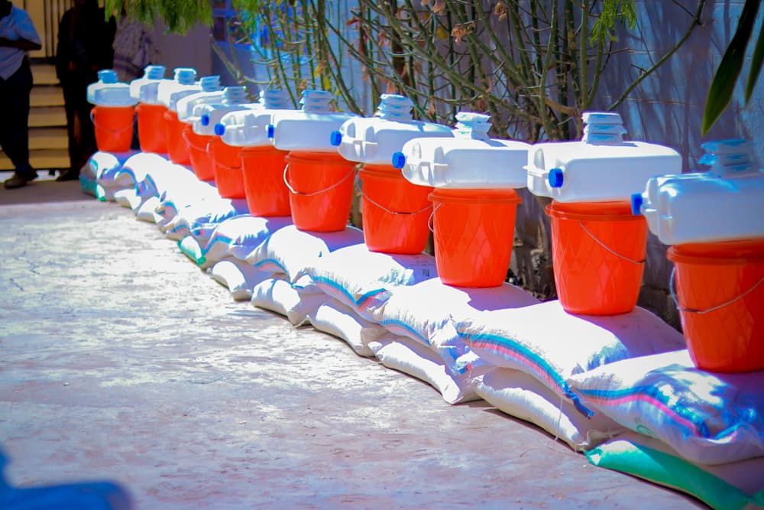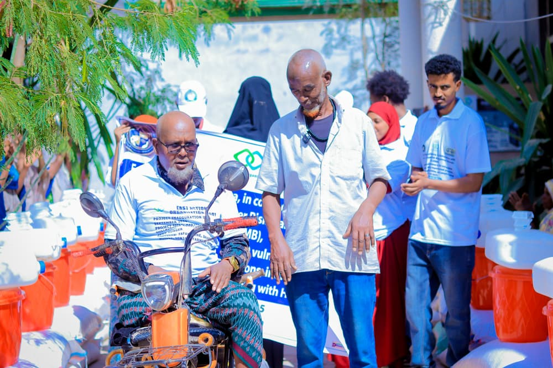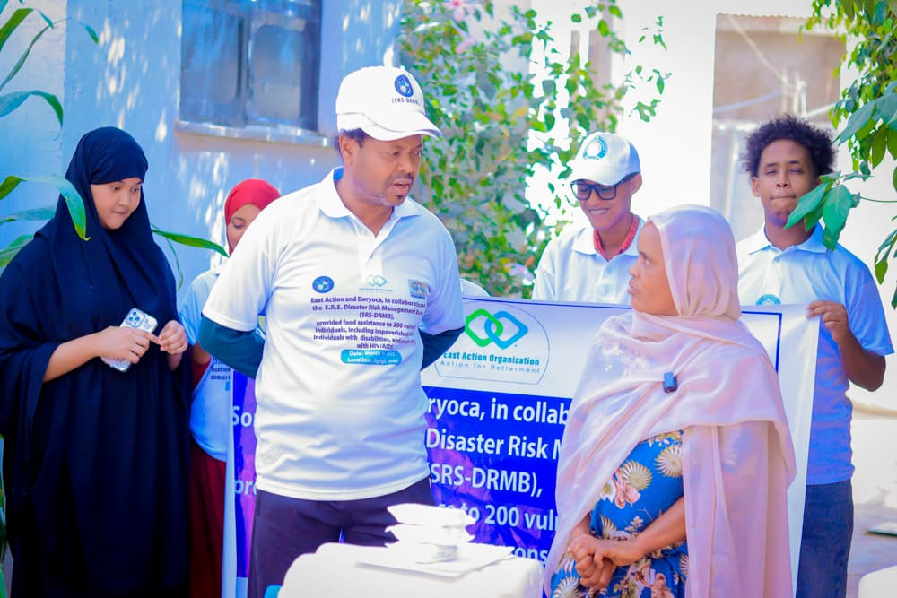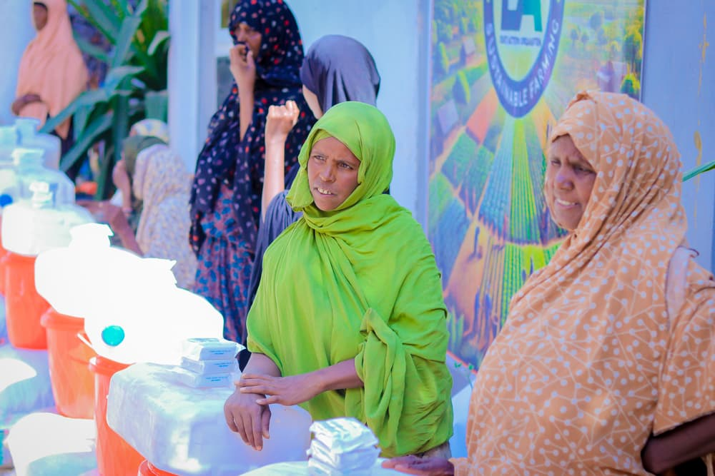

1. Introduction

East Action and Ewryoca, in partnership with the Somali Regional State Disaster Risk Management Bureau (SRS-DRMB), successfully implemented a targeted food assistance program aimed at supporting 200 of the most vulnerable individuals in Jigjiga Town. This initiative provided essential food supplies and hygiene materials to marginalized populations, including individuals with disabilities, economically disadvantaged families, elderly persons, and people living with HIV/AIDS. By addressing their immediate nutritional and hygiene needs, the program contributed to safeguarding the health and dignity of the most at-risk groups in the community.

The program was designed as part of a broader humanitarian strategy led by East Action and Ewryoca, focusing on food security, public health, and resilience-building among vulnerable communities. In addition to addressing immediate food insecurity, the initiative played a crucial role in mitigating the long-term impacts of poverty and malnutrition by ensuring that marginalized groups had access to essential resources.

Furthermore, the program fostered stronger collaboration between government entities and humanitarian organizations, reinforcing coordination mechanisms for emergency response efforts. The involvement of SRS-DRMB helped enhance the efficiency and reach of aid distribution, ensuring that assistance was delivered in a transparent and equitable manner. Additionally, the initiative set a precedent for future multi-stakeholder engagements in humanitarian interventions, demonstrating the effectiveness of locally led responses in addressing pressing food security challenges.

By integrating food assistance with broader social protection efforts, this initiative not only provided lifesaving support but also strengthened community resilience, contributing to long-term food security and improved well-being for vulnerable populations in Jigjiga Town.

Evidence and Documentation:

To maintain transparency and accountability, the distribution was fully documented through:  
1.Photographic Evidence: Capturing the distribution process and beneficiary engagement.  
2. Video Clips: Testimonies from recipients, including individuals living with HIV/AIDS, sharing how the assistance improved their well-being.  
3. Attendance and Registration Lists: Verifying that all food aid reached the targeted 200 households.

2. Objectives of the Food Assistance Program

1. Provide emergency food relief to 200 highly vulnerable households facing hunger and malnutrition.

2. Improve the nutritional well-being of individuals with disabilities and those living with HIV/AIDS, ensuring access to essential dietary needs.

3. Strengthen local humanitarian response mechanisms by working closely with SRS-DRMB to enhance aid delivery.

4. Ensure evidence-based reporting by collecting photos, video clips, and feedback from beneficiaries.

3. Distributed Items

Each household received a package containing nutrient-rich food items and hygiene materials, including:

| Item | Quantity per Household |
| --- | --- |
| 1.Macaroni | 25 kg |
| 2.White Flour | 25 kg |
| 3.Maize | 50 kg |
| 4.WASH Materials | Soap and hygiene kits |

Total Estimated Cost per Household: 4,500 ETB (including procurement, transport, and logistics).

4. Implementation and Distribution Process

4.1 Beneficiary Selection and Registration

East Action and Ewryoca teams identified the most vulnerable households in collaboration with local leaders and government authorities.

Priority was given to people living with HIV/AIDS, individuals with disabilities, and families facing extreme poverty.

A registration and voucher system was used to ensure transparency and prevent duplication.

4.2 Collaboration with SRS-DRMB

SRS-DRMB provided logistical support, helping to facilitate food transport, storage, and security during the distribution.

Government representatives supervised the distribution process to ensure compliance with humanitarian standards.

4.3 Food Distribution Event

Food items were distributed at a designated site in Jigjiga, with beneficiaries arriving at scheduled intervals.

Field officers and volunteers monitored the process, ensuring that all 200 households received their allocated support.

Photographic and video documentation was captured to verify the distribution process.

4.4 Post-Distribution Monitoring

Beneficiary interviews and video recordings were conducted to assess the impact of the food assistance.

Several recipients, including people living with HIV/AIDS, expressed how the food aid had positively impacted their health and well-being.

Feedback from the community was gathered to improve future distributions and humanitarian responses.

5. Key Results and Impact

1.200 Vulnerable Households Supported:

Each household received sufficient food and hygiene items to meet their basic needs.

2. Indirectly Benefiting 1,200 Individuals:

Since each household includes an average of six members, the assistance impacted approximately 1,200 people.

3. Improved Nutrition for People Living with HIV/AIDS:

Proper nutrition is crucial for individuals living with HIV/AIDS, as it strengthens the immune system and improves treatment outcomes.

Beneficiaries in this category shared testimonials in video clips, explaining how the food aid helped them maintain better health.

4. Strengthened Collaboration for Humanitarian Response:

This initiative demonstrated the effectiveness of partnerships between East Action, Ewryoca, and SRS-DRMB in delivering targeted aid.

6. Challenges and Lessons Learned

Challenges:

1. High Demand for Assistance – Unmet Needs Remain Critical:

The number of individuals in need exceeded the available resources. Many vulnerable families were left without assistance, highlighting the urgent need for expanded funding and future distributions.

2. Limited Resources and Budget Constraints:

The intervention was limited to 200 households, but thousands more in Jigjiga Town remain food-insecure.

More support is urgently needed to extend the program to additional at-risk communities, including more people living with HIV/AIDS, persons with disabilities, and impoverished families.

3. Logistical and Transportation Challenges:

Moving large quantities of food to different locations required additional coordination efforts.

Additional funding is needed to improve storage, transportation, and security measures for future food distributions.

4. Need for a Sustainable Solution to Food Insecurity:

While this food assistance provided short-term relief, there is a critical need for long-term solutions such as livelihood programs, income-generating projects, and vocational training to promote self-reliance.

Lessons Learned:

1. More Funding and Resources are required to expand the Program:

The high demand indicates that future humanitarian efforts should be scaled up.

2. A Multi-Sector Approach is Needed to Address Food Insecurity:

Beyond food aid, future interventions should integrate livelihood projects, vocational training, and economic empowerment programs.

3. Community and Government Engagement is Key:

Close collaboration with local authorities facilitated efficient food distribution and helped reach the most vulnerable groups.

4. Evidence-Based Humanitarian Response Strengthens Credibility:

The availability of photos, video clips, and beneficiary testimonials demonstrated transparency and accountability, reinforcing trust among donors and stakeholders.

7. Conclusion and Recommendations

This food assistance program successfully provided relief to 200 of the most vulnerable households in Jigjiga Town. However, thousands of individuals remain uncovered and in urgent need of food support, particularly people living with HIV/AIDS, persons with disabilities, and low-income families.

Recommendations for Future Interventions:

1. Expand Assistance to Cover More Vulnerable Populations  
2. Introduce Livelihood Programs for Long-Term Solutions  
3. Strengthen Partnerships for More Comprehensive Humanitarian Response

Final Note: While this report has been prepared solely by East Action, it can also be used for Ewryoca and DRMB reports.

This initiative underscores the urgent need for continued humanitarian support. The availability of photos and videos serves as clear evidence of the impact of this food distribution effort. Future initiatives should focus on scaling up assistance to ensure that no vulnerable individual is left behind.

Contact Information and Address:

Head Office: Jigjiga, Ethiopia

Behind Main Road Next to Supreme Court head office building

Zone: 2

Keble: 10

House Number: 01270

Telephone Numbers:  
+251 252 78 07 08  
+251 901 222 224  
+251 915 330 907  
+251 975 054 143

Email:  
[info@eastaction.org](mailto:info@eastaction.org)  
[dailygram@eastaction.org](mailto:dailygram@eastaction.org)  
[drnejatnejib@eastaction.org](mailto:drnejatnejib@eastaction.org)  
[sirajaden@eastaction.org](mailto:sirajaden@eastaction.org)

P.O. Box: 438

Fax: +251 252 780 706

Website: [https://eastaction.org](https://eastaction.org/)

Facebook: <https://www.facebook.com/eastaction.org/>

Location: [Google Maps](https://maps.app.goo.gl/SyaHtsT34yR6xdmF8)

Office in Addis Ababa

Zone: Bole Kifle Katama

District/Woreda: 01

House Number: New

Email: [addisababaliaison@eastaction.org](mailto:addisababaliaison@eastaction.org)

